**DATA MODEL FLOW**

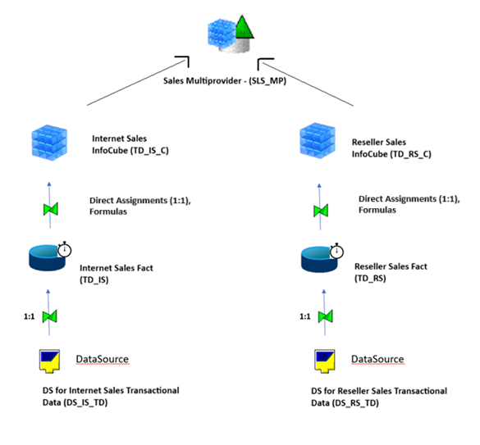

**Transformations from DSO to CUBE**

In this example we cover data transfer logic from ODSO TS_IS to CUBE TS_IS_C.

1. TD_IS.DSO.XLSX– contains TD_IS DSO structure

2. DSO - TD_IS - content.xls contains source records which have to be processed and transformed

3. TD_IS.CUBE.XLSX– contains TD_IS_C cube structure

4. CUBE - TD_IS_C - content.xls- contains the transformed records as they currently are in S13 Development system, to be used for validation of the result.

**From DSO (TD_IS) To CUBE (TD_IS_C)**

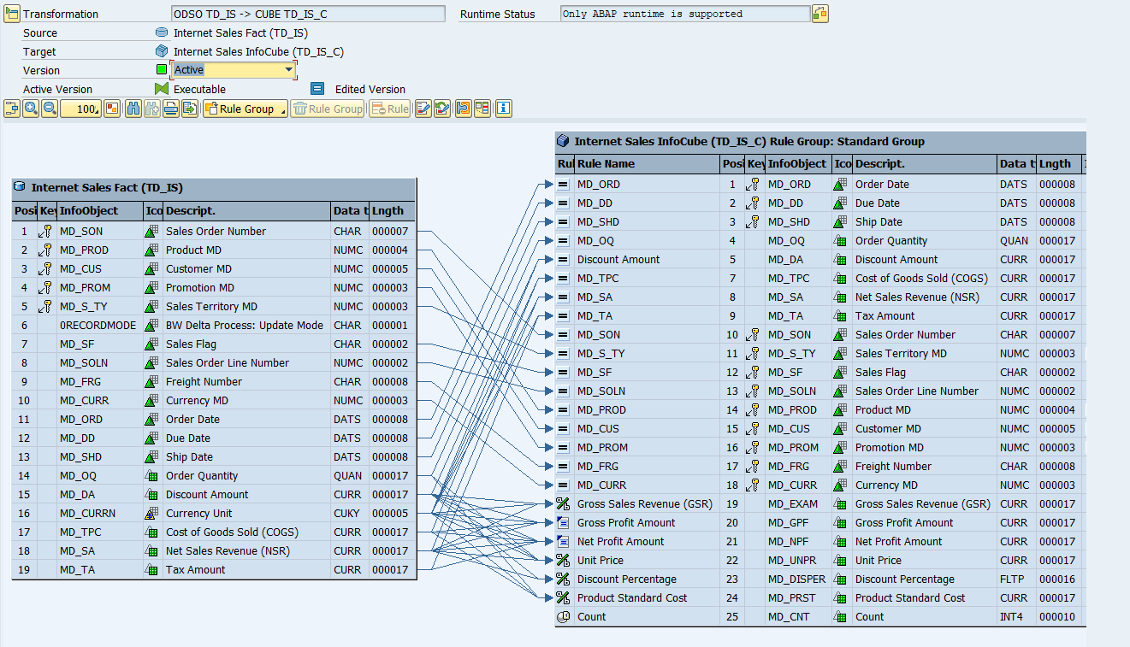

In this example we cover data transfer logic from ODSO TS_RS to CUBE TS_RS_C.

1. TD_RS.DSO.XLSX– contains TD_RS DSO structure

2. DSO - TD_RS - content.xls contains source records which have to be processed and transformed

3. TD_RS.CUBE.XLSX– contains TD_RS_C cube structure

4. CUBE - TD_RS_C - content.xls- contains the transformed records as they currently are in S13 Development system, to be used for validation of the result.

**From DSO (TD_RS) To CUBE (TD_RS_C)**

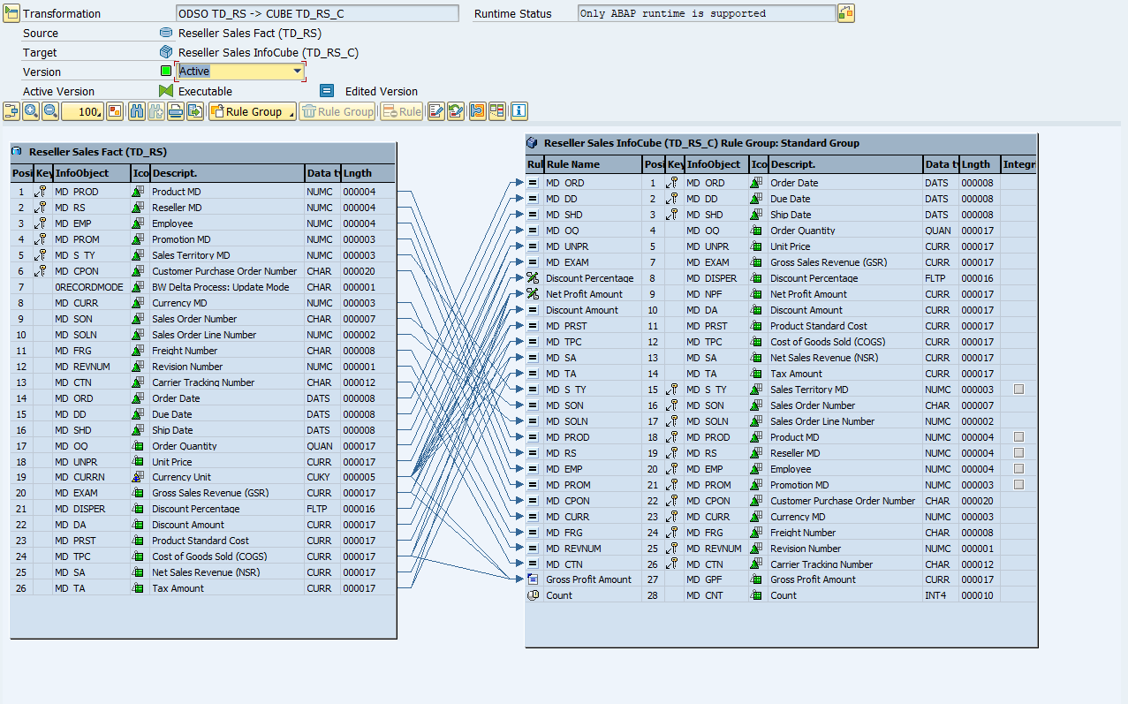

**Transformations from Datasource to DSO**

**From Datasource (DS_IS_TD) To DSO (TD_IS)**

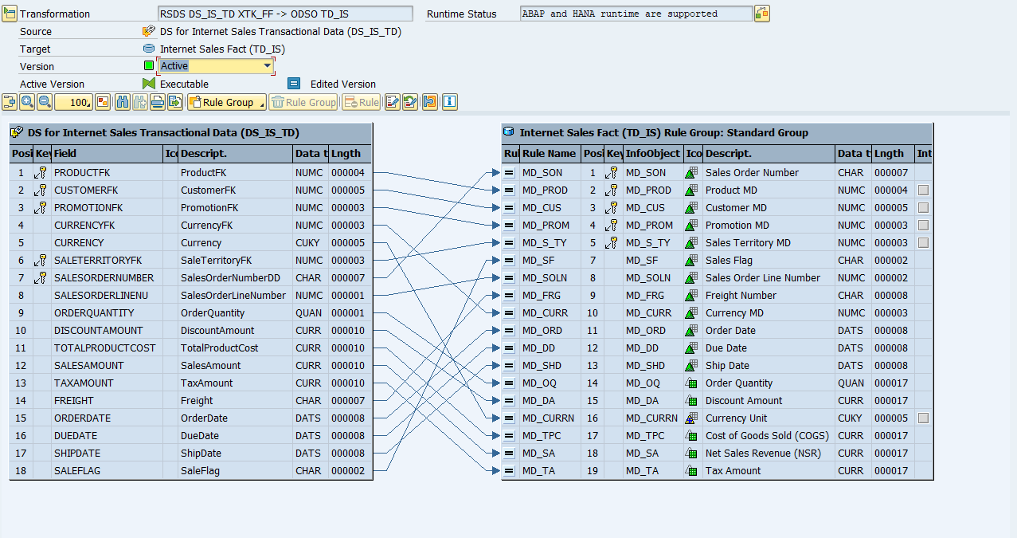

**From Datasource (DS_RS_TD) To DSO (TD_RS)**

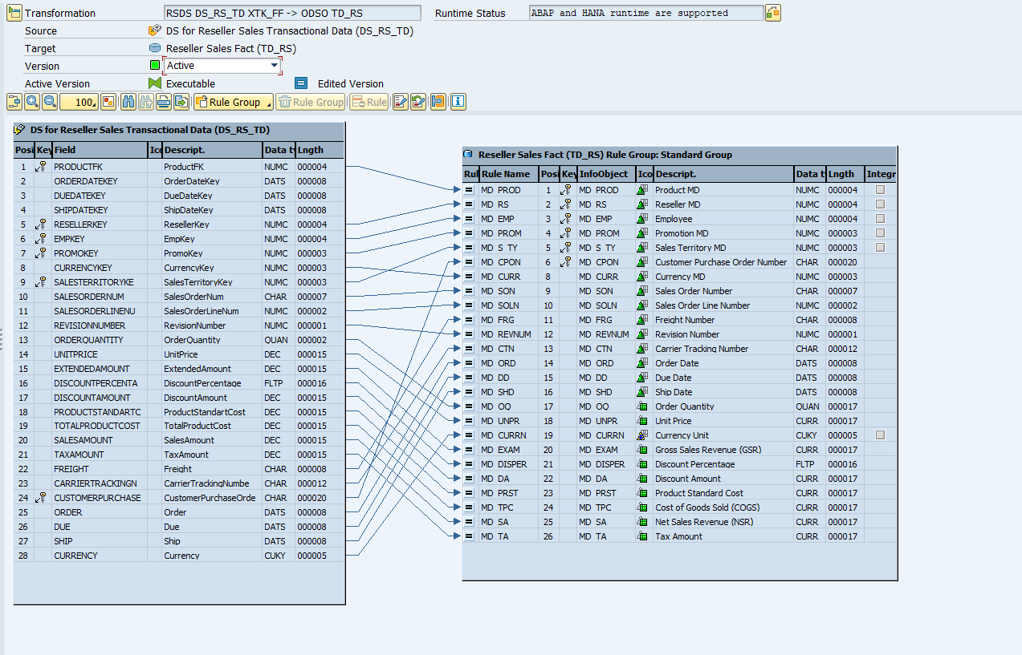

**Transformations from Datasource to Infoobject**

**From DS to Customer MD (MD_CUS) – Attributes**

**From DS to Customer MD (MD_CUS) – Texts**

**From DS to Department Group (MD_DP_GR) – Attributes**

**From DS to Department Group (MD_DP_GR) – Texts**

**From DS to Employee (MD_EMP) – Attributes**

**From DS to Employee (MD_EMP) – Texts**

**From DS to Product Category (MD_PR_CG) – Texts**

**From DS to Product MD (MD_PROD) – Attributes**

**From DS to Product MD (MD_PROD) – Texts**

**From DS to Product Subcategory (MD_PR_SC) – Attributes**

**From DS to Product Subcategory (MD_PR_SC) – Texts**

**From DS to Promotion MD (MD_PROM) – Attributes**

**From DS to Promotion MD (MD_PROM) – Texts**

**From DS to Reseller MD (MD_RS) – Attributes**

**From DS to Reseller MD (MD_RS) – Texts**

**From DS to Sales Territory MD (MD_S_TY) – Attributes**

**From DS to Sales Territory MD (MD_S_TY) – Texts**

**From DS to Currency MD (MD_CURR) – Texts**

